Agreement Relating to
Non-State Schools Transport Assistance Scheme (NSSTAS)

The Parties named below agree to the following:

________________________________________________________________(parent*)

AND ___________________________________________________________(the school).

*In this document, ‘parent’ means a student’s mother, father, legal guardian or other adult with primary parental responsibility for the student.

- That the student(s) of the above parent may travel on the transport provider indicated below to commute to and from the school.
- That the school, as the agent of the parent, will pay for the student(s) travelling on the transport provider subject to the conditions below.
- That the school will be reimbursed by the parent for the cost of providing the transport provider.
- That the school on behalf of the parent may, at its discretion, apply for assistance for which the parent may become entitled under the Non-State Schools Transport Assistance Scheme (NSSTAS).
- That the Catholic Education Queensland Limited (CEQL), as the administrator of the NSSTAS is authorised to pay to the school any assistance that the parent may become eligible for under the NSSTAS from time to time.
- That the school or bus company may charge the parent for fares not covered by NSSTAS – particularly for any amount of fare in excess of the School Transport Maximum Cash Fare Schedule (STMCFS) (per Queensland Department of Transport website).
- That the school and the parent consent to the disclosure of personal and sensitive information to CEQL and/or NSSTAS to enable the administration of NSSTAS. This information is collected through a standardised application form. This information may be shared with Government authorities, for example Centrelink (if concession card details are provided). If this information is not disclosed, full or partial payment by NSSTAS may not be possible. To view the CEQL Privacy Policy and Policy Compliance Manual, visit the website: ceql.catholic.edu.au and search for ‘privacy’.
- That the agreement will stay in place from the beginning of Semester __, 20___ until the student(s) complete(s) the education program at the school, or the school or parent cancel this agreement. Please fill in semester and year above.

Signature of parent ________________________________ Date __________________

Authorised School Representative ______________________ Date __________________

Student Name & DOB | School Attended | Transport Provider

If you, the parent, hold a Current Concession Card, please read the following information, fill in the table and sign and date this document on Page 3 as appropriate.

NB: Eligible concession cards are:
- Health Care Card (issued by Services Australia)
- Pensioner Concession Card (issued by Services Australia)
- Department of Veterans’ Affairs Pensioner Concession Card.

Confirmation of information provided:

I, the applicant (Parent/Carer) authorise:
- the Catholic Education Queensland Limited (CEQL) to use Centrelink Confirmation eServices to perform a Centrelink or DVA enquiry of my Centrelink or Department of Veterans’ Affairs customer details and concession card status to enable the business to determine if I qualify for a concession, rebate or service.
- Services Australia to provide the results of that enquiry to the CEQL.

I understand that:
- Services Australia will disclose personal information to the CEQL including my name, postcode, concession card type, deceased status, payment type, and payment status to confirm my eligibility for a NSSTAS concessional rebate provided by the CEQL.

- this consent, once signed, remains valid while I am a customer of the CEQL unless I withdraw it by contacting the CEQL or Services Australia. I can get proof of my circumstances or details from Services Australia and provide it to the CEQL so they can determine my eligibility for the NSSTAS concessional rebate.
- if I withdraw my consent or don’t alternatively provide proof of my circumstances or details, I may not be eligible for the NSSTAS concessional rebate provided by the CEQL.

Signed as per Page 3 of this Agreement.

Dated as per Page 3 of this Agreement.

Health Care Card (HCC):
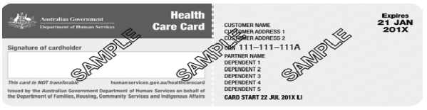
CRN:
Expiry Date:
Pensioner Concession Card (PCC):
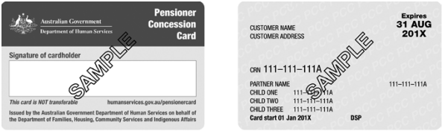
CRN:
Expiry Date:
Department of Veterans’ Affairs Pensioner Concession Card (DVA)*
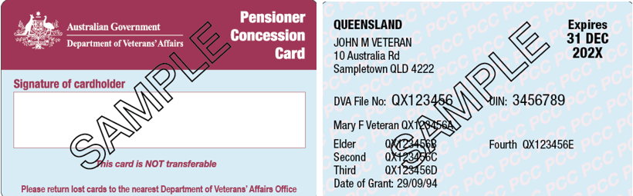
DVA:
Expiry Date: * A DVA Health Card is not acceptable.

Signature of parent ___________________________________ Date _________________

