Agreement Relating to
Non State Schools Transport Assistance Scheme (NSSTAS)

The Parties named below agree to the following:

______________________________________________________________________ (parent*)

AND __________________________________________________________________ (the school).

*In this document, ‘parent’ means a student’s mother, father, legal guardian or other adult with primary parental responsibility for the student.

- That the student(s) of the above parent may travel on the transport provider indicated below to commute to and from the school.
- That the school, as the agent of the parent, will pay for the student(s) travelling on the transport provider subject to the conditions below.
- That the school will be reimbursed by the parent for the cost of providing the transport provider.
- That the school on behalf of the parent may, at its discretion, apply for assistance for which the parent may become entitled under the Non State Schools Transport Assistance Scheme (NSSTAS).
- That the Queensland Catholic Education Commission (QCEC), as the administrator of the NSSTAS is authorised to pay to the school any assistance that the parent may become eligible for under the NSSTAS from time to time.
- That the school or bus company may charge the parent for fares not covered by NSSTAS – particularly for any amount of fare in excess of the School Transport Maximum Cash Fare Schedule (STMCFS) (per Queensland Department of Transport website).
- That the agreement will stay in place from the beginning of Semester __, 20___ until the student(s) complete(s) the education program at the school, or the school or parent cancel this agreement.
- That the school and the parent consent to the disclosure of personal and sensitive information to QCEC and/or NSSTAS to enable the administration of NSSTAS. This information is collected through a standardised application form. This information may be shared with Government authorities, for example Centrelink (if concession card details are provided). If this information is not disclosed, full or partial payment by NSSTAS may not be possible. To view the QCEC Privacy Policy and Policy Compliance Manual, visit the website: qcec.catholic.edu.au and search for ‘privacy’.

Signature of parent ___________________________________ Date ______________

Authorised School Representative ___________________________________ Date ______________

Student Name & DOB | School Attended | Transport Provider

(If you, the parent, hold a Current Concession Card, please complete over the page) ……..

NB: Eligible concession cards are:
- Health Care Card (issued by Services Australia)
- Pensioner Concession Card (issued by Services Australia)
- Department of Veterans’ Affairs Pensioner Concession Card.

Parent current Australian Government issued concession card details:

I, the applicant (Parent/Carer) authorise:
- the Queensland Catholic Education Commission (QCEC) to use Centrelink Confirmation eServices to perform an Australian Government Services Australia or Department of Veterans’ Affairs (DVA) enquiry of my Centrelink or DVA customer details and concession card status in order to enable the QCEC to determine if I qualify for a concession, rebate or service.
- the Australian Government Services Australia (the Agency) to provide the results of that enquiry to the QCEC.

I understand that:
- the Agency will use information I have provided to the QCEC to confirm my eligibility for a NSSTAS concessional rebate and will disclose to the QCEC personal information including my name, address, payment and concession card type and status.
- this consent, once signed, remains valid while I am a customer of QCEC unless I withdraw it by contacting the QCEC or the Agency.
- I can obtain proof of my circumstances/details from the Agency and provide it to QCEC so that my eligibility for a NSSTAS concessional rebate can be determined.
- if I withdraw my consent or do not alternatively provide proof of my circumstances/details, I may not be eligible for the NSSTAS concessional rebate provided by QCEC.

Health Care Card (HCC)  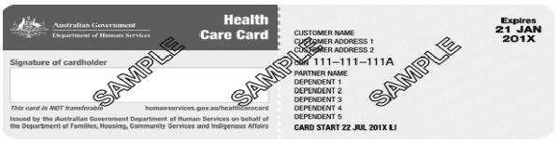 | CRN | Expiry Date:
Pensioner Concession Card (PCC)  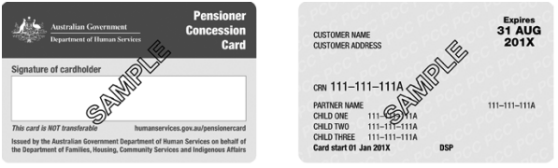 | CRN | Expiry Date:
Department of Veterans’ Affairs Pensioner Concession Card (DVA)*  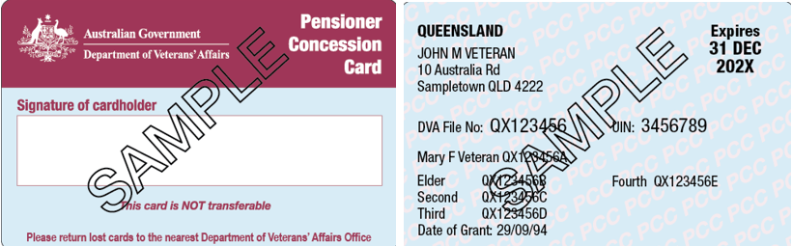  * A DVA Health Card issued by the Department of Veterans’ Affairs is not acceptable. | DVA | Expiry Date:

Signature of parent ___________________________________________ Date ______________

